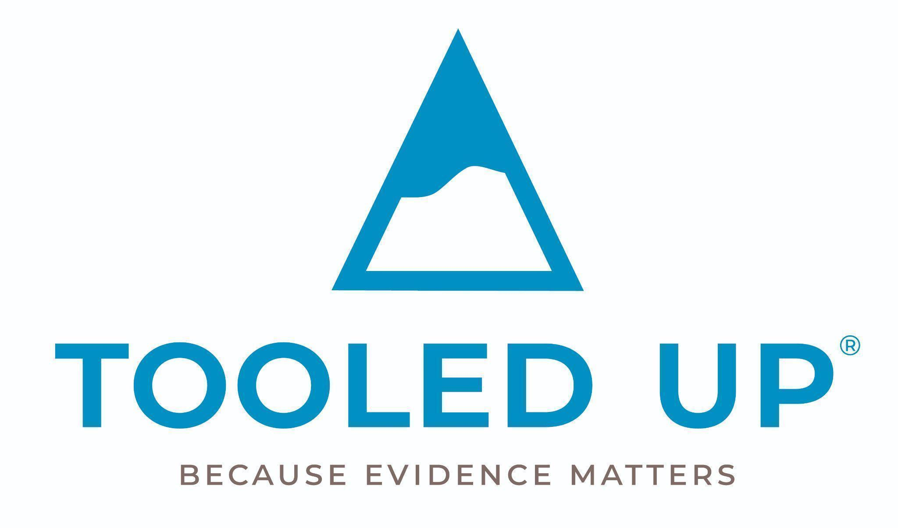

Parenting is a journey and no-one would ever set off on a journey without some tools, ideas and strategies for navigating the path ahead. Our school aims to ensure that all parents and carers have full access to a digital platform that ensures you are staying up to date with contemporary issues related to modern-day parenting and that you have access to actionable ideas derived from the highest quality research evidence.
Tooled Up is curated by one of the UK’s leading experts on parental engagement in children’s lives and learning, Dr Kathy Weston and her experienced research team.
There are huge benefits for you as a family when you register your Tooled Up Education account. To summarise:
As a ‘Tooled Up’ parent, you will:
- Be able to ask questions about any aspect of your child’s life and get evidence-based answers that can inform parenting approaches at home.
- Be able to attend live webinars, online talks, Q&As with experts and whole-day online conferences.
- Be able to request resources (for you as a family or for your child to use).
Register your account now:
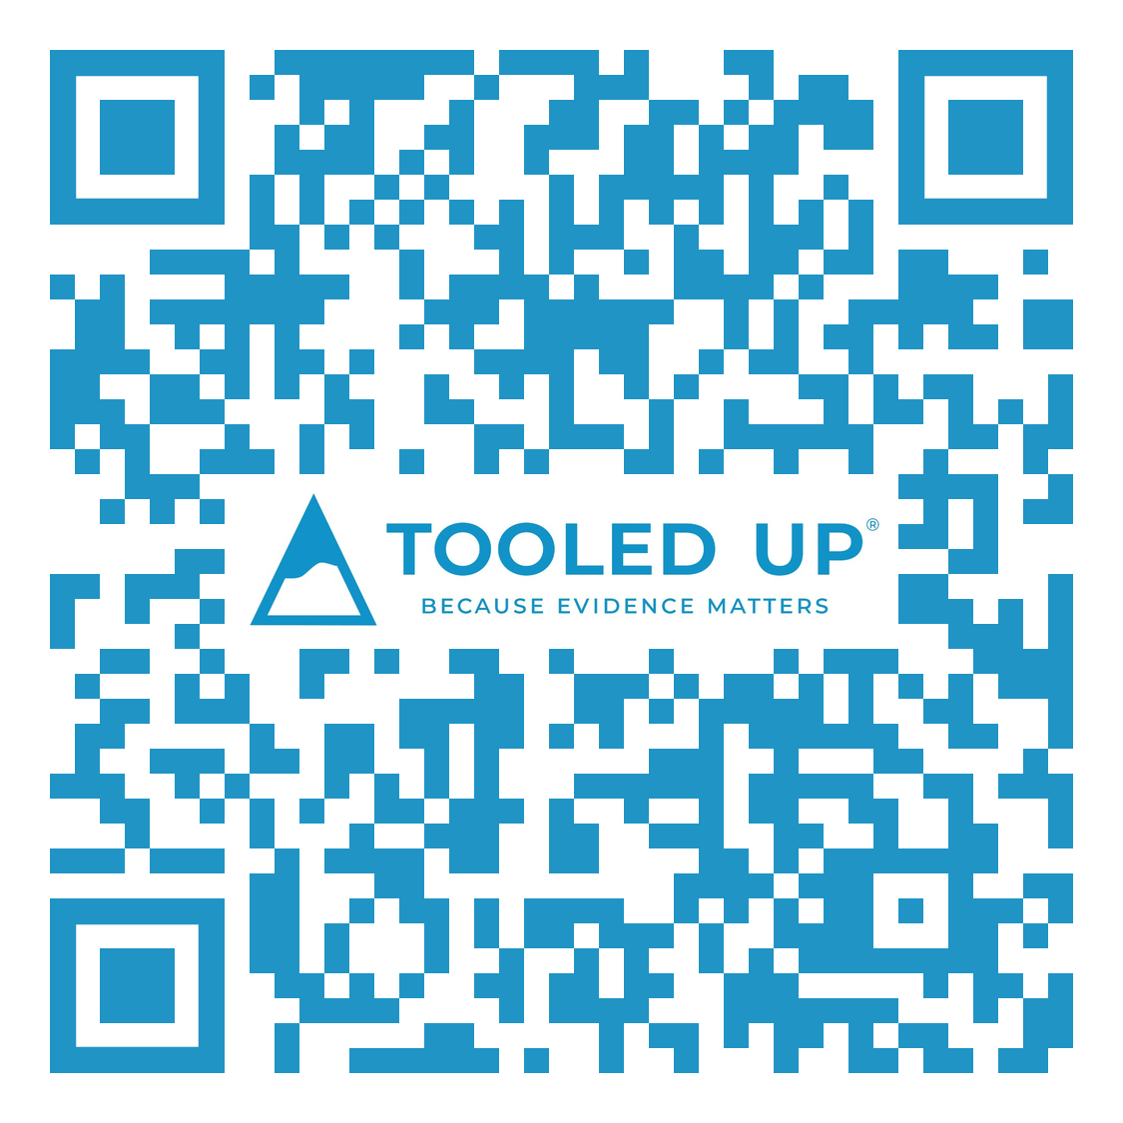
Click on the link below to set up your personal account by entering your email address and our school PIN. We have sent you an email containing our unique school PIN. If you can’t find it, contact the school office.
Create my Tooled Up Account
Once you have created your account, you will have immediate access to the entire Tooled Up platform.
You can view all the resources on your phone too. Click the link if viewing this on your phone, or scan the QR code with your phone camera if not, to access the site that way.
Stay close to us to make the most of our support
When logged into Tooled Up, go to the ‘Account’ page and check that you have ticked the box to let the Tooled Up team know you are happy to hear from them. They will send occasional notification of upcoming webinars or resource updates.
If you have any questions, please do not hesitate to contact the school office or Tooled Up directly on office@tooledupeducation.com

